**Battery Health Monitoring System by State Of Charge Estimation Using Artificial Neural Network**

**Aim:**

Today Battery is an integral part of all critical electrical systems. Batteries store chemicals, not electricity. Two separate leads in an acid compound reacts to produce electrical pressure. This chemical reaction converts chemical energy into electrical energy. Some batteries are sensitive to overcharging and deep discharge, which can lead to permanent damage. So all these standing batteries need regular maintenance to identify and fix problems. Visual testing can detect physical problems, electrical tests can identify charging and charging problem. And the state of the test results check the electrolyte strength. This paper introduces the design of an efficient battery monitoring system that can be easily integrated into a variety of batteries, captures information about battery status and sends information to an authorized person. And to accurately measure the charge level (SOC) using the most accurate, robust, stable method such as Artificial Neural Networks (ANN). It will help prevent excessive and excessive battery use which ultimately leads to longer battery life.

**Software & Hardware Requirement:**

1. Microcontroller ARM LPC2138
2. Battery
3. signal conditioning circuit
4. LCD JHD16X2A
5. LM35 temperature sensor
6. Ultrasonic sensor (HCSR04)
7. Zigbee modules

**Project Flow:**

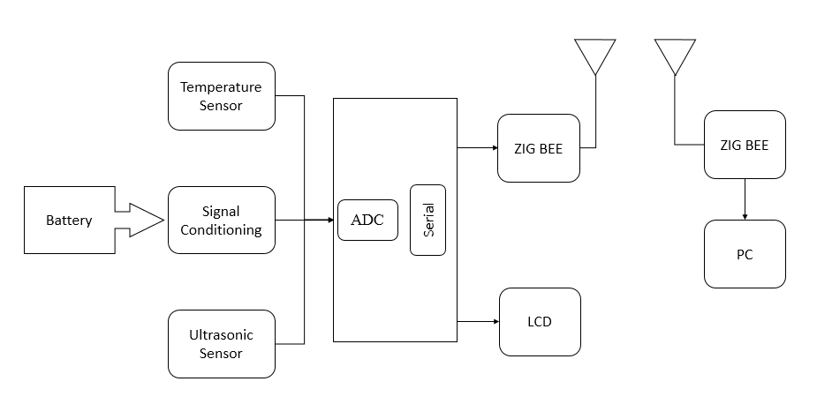

**Proposed Model:**

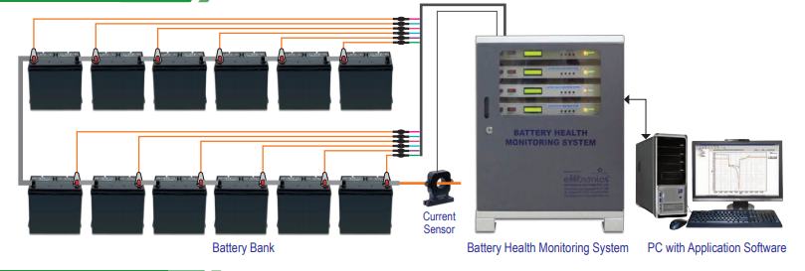

**Stake holders:**

Generally many industries, vehicles and many hi-ended equipment’s use Battery Management Systems (BMS) to monitor and control battery banks so they are the main stake holders.

Then comes the manufacturers of these battery some advancements on these prototypes.

Finally comes the research department who work on these modules to make it simpler and better.